Pike County Career Technology Center
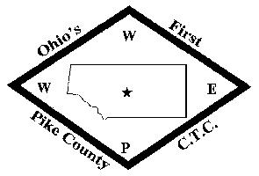
Adult Education

Plan: Student Personnel Services

Objective: To determine the effectiveness of the student services. To identify student services that need improvement and to develop a plan of improvement.

Evaluated: Evaluated by the compiled data from student evaluation surveys.

Timeline: Annually

Responsible for coordination of student services:
Overall responsibility for coordination Adult Education Director
Academic advisement and counseling Aspire Instructors / Adult Education Director
Financial Aid Adult Education Office Staff
Orientation Adult Education Director / Instructors
Retention Adult Education Director
Grievances Adult Education Director / Superintendent
Health and Safety Adult Education Director
Records Adult Education Office Staff

Effectiveness:
Student evaluation forms will be completed by students who attend the Pike CTC. These evaluation tools will provide the student the opportunity to provide a qualitative and quantitative assessment concerning all aspects of their student experience, including student services received.
Effectiveness of the student support services will be determined through the collection and analysis of these student evaluations concerning the different aspects of student services received at the Pike CTC.

Counseling:
Academic counseling is provided by Aspire Instructors. Aspire Instructors can provide remediation services for basic academic skills (reading & math) and help provide study strategies.
Students who need mental care services or mental health counseling are referred to:
Scioto Paint Valley Mental Health
102 Dawn Lane
Waverly OH 45690
740-947-7783
https://spvmhc.org/

Documenting annual evaluation:
At the conclusion of each school year, student evaluation forms will be compiled into a survey system (surveymonkey.com) and a comprehensive report will be generated. The overall evaluation measures for student services, and other aspects of the student experience, will be documented and kept on file.

Disseminating results to staff so that pertinent information can be used to improve the student personnel services:
A formal annual evaluation of student services is done as part of the Strategic Planning meeting process. Results are analyzed and strategies are developed and initiated to improve the effectiveness of student services.

